August Newsletter
Audubon Elementary
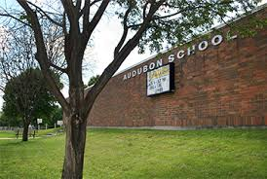

Important Dates

[Date]
[Event Name]

[Date]
[Event Name]

[Date]
[Event Name]

Important Announcement
[To replace a photo with your own, just right-click it and then choose Change Picture.]

605 Lincoln Ave. Dubuque, IA 52001
T: (563)582-3300 E: lroussel@dbqschools.org
W: http://msroussel2ndgrade.weebly.com/
Hello 2nd Grade Families,
This will be the newsletter you see come home monthly. Attached will be the calendar for the month. I will post this newsletter as well as the calendar on the classroom website. Please see the URL above for link to website.

Reading

Math

More Important News

In the Community

[Event Name]
[You can add a description and key information about event here.]

[Event Name]
[You can add a description and key information about event here.]

Science

Social Studies

Writing

Specialist

